

**Proposal and Quotation BotMaster WhatsApp Bulk Messaging**

https://www.veloxn.com/

**Introduction –**

Thank You for showing interest in BotMaster, WhatsApp Bulk Messaging Software with Veloxn Private Limited

**Service Cost -**

The table below details the cost associated with this service.

|  |  |  |  |
| --- | --- | --- | --- |
| **Name** | **Unit Price** | **Year** | **Subtotal** |
| BotMaster - WhatsApp Bulk Messaging Software | ₹5,000 | 1 | ₹5,000 |
| Proposal and Quotation for 1Lac Bulk WhatsApp Massages with virtual number | ₹10,000 |  | ₹10,000 |
| **TOTAL** |  |  | ₹ 15,000 |
| **GST 18 %** |  |  | ₹2,700 |
| **TOTAL Including GST** |  |  | **₹17,700** |

Payment required is **₹ 17,700**

**Note\*** - Offer Valid for 7 Days only

**Bank Details**:

**VELOXN PRIVATE LIMITED**

AC Number – 259958439076

IFSC Code – INDB0000702

Bank Name – Indusind Bank

UPI ID - veloxnservices@okicici

QR Code – 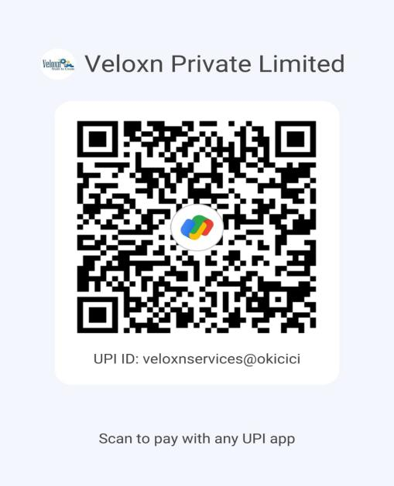

**COMPANY:**

Veloxn Private Limited

Iconic Tower C, Corenthum, Sector-62, Noida, UP - 201301, India www.veloxn.com

sales@veloxn.com

91-7292001010

GST - 06AAICV7138B1ZE